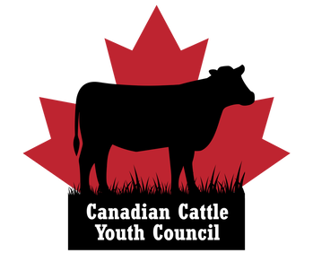

2023 Member at Large Nomination Form

The Canadian Cattle Association (CCA) Canadian Cattle Youth Council is accepting nominations for a two-year term Member at Large position. Election results will be announced at the Youth Council Annual General Meeting on August 15, 2023, in Calgary, Alberta at the Canadian Beef Industry Conference. Options are being explored to allow nominees and youth council members to attend virtually or call in.

Please complete the form below to put your name forward for the Member at Large position on
the Council and submit by email to radauj@cattle.ca by Monday, July 17, 2023.
Eligibility Requirements of the Member at Large:
- Age 18-40
- Must be a producer paying check-off dollars, or an employee of an operation paying check-off.
- Must be a member of the Canadian Cattle Youth Council
  - Join for free at www.canadiancattleyouthcouncil.ca.
**Please submit a video bio, rather than a written bio. In addition to this form, please submit a short (approximately one-minute) video bio of yourself highlighting why you would be the best candidate for the position to the same email address. Cellphone filming is acceptable, however, please ensure the video is filmed horizontally. The videos will then be circulated with the youth council membership for electronic voting in the weeks ahead of the youth council AGM.
For additional information, please visit our website at canadiancattleyouthcouncil.ca to learn more about the Canadian Cattle Youth Council. Please direct any questions to radauj@cattle.ca.

Full Name: Age as of January 1, 2023 (Must be ages 18-40):

Telephone: Email:

Province:

Please circle your responses to the following questions.
- Are you a member of the Canadian Cattle Youth Council?
(You must be a member to serve on the Board. Join for free at canadiancattleyouthcouncil.ca/join-the-council)
YES NO

- Are you a member of a provincial organization affiliated with the Canadian Cattle Association?
YES NO
If so, which organization:

- Are either of your parents or employer a member of a provincial organization affiliated with the Canadian Cattle Association?
YES NO
If so, which organization:

- If you answered “NO” to questions 1 and 2, please describe your involvement with the Canadian beef industry.

- Are you in good standing with the CCA, provincial organizations, and affiliated programs? (ex. Canadian Cattle Young Leaders Mentorship Program)

YES NO

6. I have read the delegate overview on the following pages and understand the responsibilities of serving on the Canadian Cattle Youth Council and confirm I meet the eligibility requirements to serve as a Member at Large.
YES NO

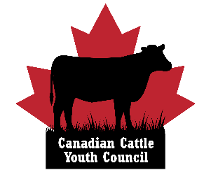
Canadian Cattle Youth Council
Delegate Overview

What is the Canadian Cattle Youth Council?

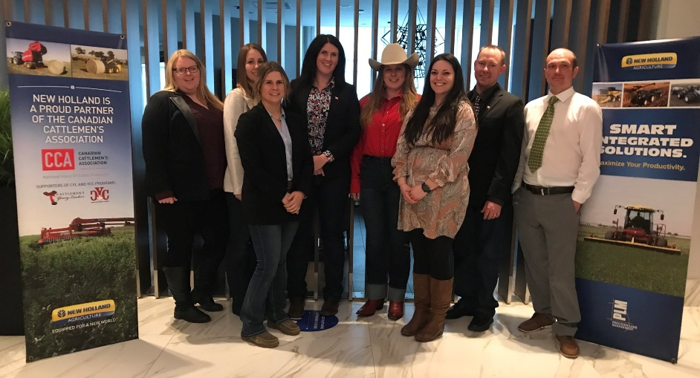
It is the vision of the Canadian Cattle Association’s (CCA) Canadian Cattle Youth Council to cultivate youthful leadership through exposure to industry policy development, while allowing young producers the opportunity to gain experience and bring fresh insight to the table. The youth council also strives to be a conduit for information between industry organizations and the youth of the beef industry.

The council represents Canadian beef farmers and ranchers ages 18-40. The council is made up of 10 delegates; with seven provincial representatives and three members at large.

The main goal of the youth council is to expose young people to CCA’s innerworkings, preparing them to step into leadership roles within their provincial organizations, and within CCA in the future. The youth council provides hands-on governance and board training within the Canadian beef realm.

Delegates have the opportunity to serve on CCA policy committees as ex-officio members to gain experience and provide youthful perspective on current issues. This provides the council with the opportunity to bring forward ideas and issues of importance to young beef producers, and to comment on discussions at the CCA level in a non-voting capacity.

The council also takes part in various domestic and international events, roundtables, and meetings as a voice for Canada’s next generation of cattle producers.

What events do youth council delegates attend?

Delegates are expected to participate in monthly conference calls. The conference call meetings are designed to be a touch point for the council to plan engagement with young producers and the general youth council membership, explore engagement with CCA and plan activities.

Each year, two youth council delegates are invited to attend the annual National Western Stock Show trip in conjunction with the CCA’s Canadian Cattle Young Leaders mentorship program. The youth council President may also be invited to participate in international beef industry events.

Youth council delegates are expected to attend events such as the CCA Annual General Meeting (AGM) in Ottawa held every March, and the youth council Semi-Annual meeting is held during the CCA AGM. Delegates may also be invited to attend the annual youth council fly-in meetings on Parliament Hill, held in conjunction with the CCA AGM.

The youth council AGM takes place at the Canadian Beef Industry Conference in August, in conjunction with the CCA Semi-Annual meeting. The hosting city rotates each year. Delegates are expected to attend both the youth council AGM and Semi-Annual meetings. Thanks to the generous support of our youth council Platinum Partner, New Holland, provincial members and the Canadian Cattle Association, travel costs for delegates are covered.

What are the responsibilities of a delegate?

- Participate in monthly conference calls.
- Sit on a youth council committee (Governance, Promotions or Nominations/Membership) and work with fellow delegates within the committee to help plan events and activities throughout the year. Delegates are also asked to serve on ad hoc youth council committees as necessary.
- Attend the CCA AGM in March and the Canadian Beef Industry Conference/CCA semi-annual meeting in August to participate in youth council and CCA meetings.
- Serve as an ex-officio member on a CCA policy committee. This includes attending the committee meetings (main ones at CCA AGM and Semi-Annual) and writing reports on committee activities to communicate with the youth council membership.
- Participate in virtual training events (Ex. Governance or Media Training).
- Contribute content to the youth council newsletter and social media channels as needed.
- Participate in the youth council’s advocacy outreach activities that support CCA policy priorities.

What is the criteria to be a Member at Large?
- Age 18-40
- Must be a producer paying check-off dollars, or an employee of an operation paying check-off.
- Must be a member of the Canadian Cattle Youth Council
  - Join for free at www.canadiancattleyouthcouncil.ca.
Questions? Please reach out!
Jessica Radau
Canadian Cattle Association
Youth Leadership Coordinator
radauj@cattle.ca or 403-336-2146

Learn more: www.canadiancattleyouthcouncil.ca

