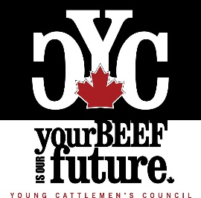

2021 Member at Large Nomination Form
The Canadian Cattlemen’s Association (CCA) Young Cattlemen’s Council (YCC) is accepting nominations for a two-year term Member at Large position. Election results will be announced at the YCC Annual General Meeting on August 17, 2021 in Calgary, AB. The YCC membership and nominees will be invited to attend virtually.

Please complete the form below to put your name forward for the Member at Large position on
the Council and submit by email to gilesj@cattle.ca by August 6, 2021.
**Please submit a video bio, rather than a written bio. In addition to this form, please submit a short approximately one-minute video bio of yourself highlighting why you would be the best candidate for the position to the same email address. Cellphone filming is acceptable, however please ensure the video is filmed horizontally. The videos will then be circulated with the YCC membership for electronic voting.
For additional information, please visit our website at www.youngcattlemenscouncil.com to learn more about the Young Cattlemen’s Council. Please direct any questions to gilesj@cattle.ca

Full Name: Age as of January 1, 2021:

Telephone: Email:

Province:

Please circle your responses for the following questions.
- Are you a member of the Young Cattlemen’s Council?
(You must be a member to serve on the YCC Board. Join for free at youngcattlemenscouncil.com)
YES NO

- Are you a member of a provincial organization affiliated with the Canadian Cattlemen’s Association?
YES NO
If so, which organization:

- Are either of your parents a member of a provincial organization affiliated with the Canadian Cattlemen’s Association?
YES NO
If so, which organization:

- If you answered “NO” to questions 1 and 2, please describe your involvement with the Canadian beef industry.

- Are you in good standing with the CCA, provincial organization, and affiliated programs? (ex. Cattlemen’s Young Leaders Mentorship Program)

YES NO

6. I have read the delegate overview on the following pages and understand the responsibilities of serving on the Young Cattlemen’s Council.
YES NO

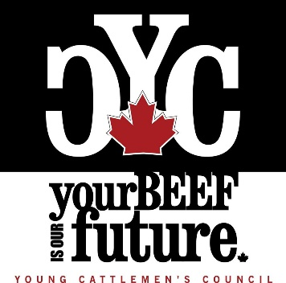
Young Cattlemen’s Council
Delegate Overview

What is the Young Cattlemen’s Council (YCC)?

It is the vision of the Canadian Cattlemen’s Association (CCA) Young Cattlemen’s Council to cultivate youthful leadership by exposure to industry policy development, while allowing delegates the opportunity to gain experience and bring fresh insight to the table. The YCC also strives to be a conduit of information between industry organizations and the youth of the beef industry.

YCC represents Canadian beef cattle enthusiasts ages 18-40. The YCC Board is made up of nine delegates; six provincial representatives and three members at large.

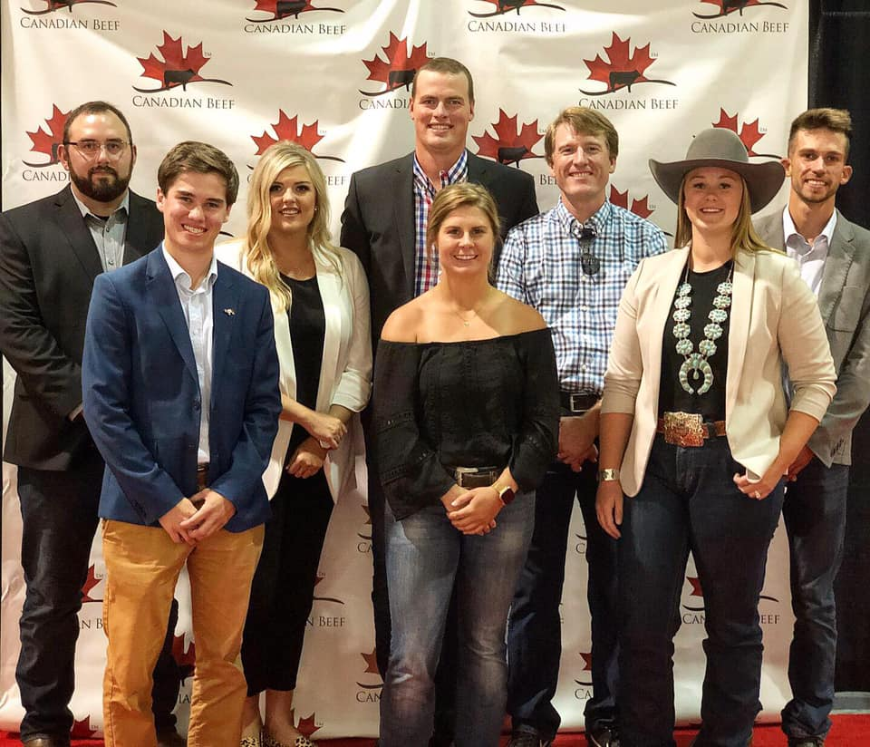
The main goal of the YCC is to expose young people to the innerworkings of the Canadian Cattlemen’s Association, preparing them to step into leadership roles within their provincial organizations, and within the CCA in the future. The YCC acts as hands-on governance and board training within the Canadian beef realm.

Delegates have the opportunity to serve on CCA committees as ex-officio members to gain experience and provide youthful perspective on current issues. This provides the Council with the opportunity to bring forward ideas and issues of importance to young producers, and to comment on discussions at the CCA level in a non-voting capacity.

The board also takes part in various domestic and international events, roundtables and meetings as a voice for Canada’s next generation of cattle producers.

What events do YCC delegates attend?

Delegates are expected to participate in monthly conference calls. The conference call meetings are designed to be a touch point for the Council to plan engagement with young producers and the general YCC membership, explore engagement with CCA and plan activities.

Each year, two YCC delegates are invited to attend the annual National Western Stock Show and Rodeo trip in conjunction with the CCA’s Cattlemen’s Young Leaders Program. The YCC President may also be invited to participate in international beef industry events.

Other events that YCC delegates are expected to attend are the CCA Annual General Meeting (AGM) in Ottawa held every March. The YCC Semi-Annual meeting is hosted during the CCA AGM in Ottawa. YCC delegates may also be invited to attend the annual YCC fly-in to lobby on Parliament Hill, held in conjunction with the CCA AGM.

The YCC AGM takes place at the Canadian Beef Industry Conference in August, in conjunction with the CCA Semi-Annual meeting. The hosting city rotates each year. YCC delegates are expected to attend both the YCC AGM and Semi-Annual meetings. Thanks to the generous support of our YCC Platinum Partner, New Holland, and provincial members, travel costs for delegates are covered.

What are the responsibilities of a delegate?

- Participate in monthly conference calls
- Sit on a YCC Committee (Governance, Promotions or Nominations/Membership) and work with fellow delegates within the committee to help plan events and ideas throughout the year.
- Serve as an ex-officio member on a CCA Committee. This includes attending the committee meetings (main ones at CCA AGM and Semi-Annual) and writing reports on committee activities to communicate with the YCC Membership
- Participate in virtual training events (Ex. Governance or Media Training)
- Contribute content to the YCC newsletter as needed

Questions? Please reach out!
Jessica Giles
Canadian Cattlemen’s Association
Youth Leadership Coordinator
gilesj@cattle.ca

Learn more: http://youngcattlemenscouncil.com/

Canadian Cattlemen’s Association
Established in 1932, the Canadian Cattlemen’s Association (CCA) is the only national organization representing the interests of Canada's 55,000 beef producers. Twenty-seven producers from nine provinces make up the CCA board of directors. CCA provides the leadership and unity necessary to speak as one voice for the beef industry. This includes assisting in its development, adaptation to new ideas and technologies, and in its prosperity. CCA is structured to represent every phase of the production system; including purebred, cow/calf, backgrounding and feedlot sectors.
CCA is involved in a wide range of issues that are of concern to Canadian beef producers. These include trade, animal health, environment and animal care, fiscal and monetary policy, and grading/inspection, to name just a few. In addition, CCA works closely with other sectors of the agriculture and food industries on matters of mutual concern.

