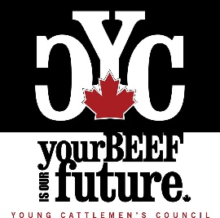

2020 Member at Large Nomination Form
The Canadian Cattlemen’s Association (CCA) Young Cattlemen’s Council (YCC) is accepting nominations for a two-year term Member at Large position. Election results will be announced at the virtual YCC Annual General Meeting on August 6, 2020.

Please complete the form below to put your name forward for the Member at Large position on
the Council and submit by email to gilesj@cattle.ca by July 27, 2020.
**New this year** Please submit a video bio, rather than a written bio. In addition to this form, please submit a short approximately one-minute video bio of yourself highlighting why you would be the best candidate for the position to the same email address. Cell phone filming is acceptable, however please ensure the video is filmed horizontally.
For additional information, please visit our website at www.youngcattlemenscouncil.com to learn more about becoming involved with the Council. Please reach out with any additional questions through the website Contact page.

Full Name: Age as of January 1, 2020:

Telephone: Email:

Province:

Please circle your responses for the following questions.

- Are you a member of the Young Cattlemen’s Council?
(You must be a member to serve on the YCC Board. Join for free at youngcattlemenscouncil.com)
YES NO

- Are you a member of a provincial organization affiliated with the Canadian Cattlemen’s Association?
YES NO
If so, which organization:

- Are either of your parents a member of a provincial organization affiliated with the Canadian Cattlemen’s Association?
YES NO
If so, which organization:

- If you answered “NO” to questions 1 and 2, please describe your involvement with the Canadian beef industry.

- Are you in good standing with the CCA, provincial organization, and affiliated programs? (ex. Cattlemen’s Young Leaders Mentorship Program)

YES NO

